

**Lab No: 6 Date: 2082/**

**Title: Write a program to calculate the average turnaround time and waiting time for user input process parameters using RR process scheduling algorithm.**

Round Robin (RR) is a preemptive CPU scheduling algorithm that assigns each process a fixed time quantum. The CPU cycles through processes in the ready queue, giving each process a fair share of CPU time. If a process doesn’t finish within its time quantum, it goes back to the queue to wait for the next turn.

Algorithm:

Step 1: Start with the list of processes and note their arrival time and burst time.

Step 2: Choose a fixed time quantum.

Step 3: Arrange processes in the ready queue in the order of arrival.

Step 4: Allocate CPU to the first process for one time quantum.

Step 5:

* If the process completes, remove it from the queue.
* If not, reduce its remaining burst time and put it back at the end of the queue.

Step 6: Repeat Step 4 and Step 5 until all processes are completed.

Step 7: Calculate waiting time and turnaround time for each process, then compute averages.

Step 8: Stop.

**Language**: C++

**IDE**: VS Code

**Code:**

**#include <iostream>**

**#include <vector>**

**#include <queue>**

**using namespace std;**

**struct Job {**

**int jobId;**

**int burst;**

**int remaining;**

**int arrival;**

**int completion;**

**int tat;   // Turn Around Time**

**int wt;    // Waiting Time**

**};**

**int main() {**

**int totalJobs, timeSlice;**

**cout << "Enter number of processes: ";**

**cin >> totalJobs;**

**vector<Job> taskList(totalJobs);**

**// Assume all processes arrive at time 0**

**for (int j = 0; j < totalJobs; j++) {**

**taskList[j].jobId = j + 1;**

**taskList[j].arrival = 0;**

**cout << "Enter burst time for process " << j + 1 << ": ";**

**cin >> taskList[j].burst;**

**taskList[j].remaining = taskList[j].burst;**

**}**

**cout << "Enter Time Quantum: ";**

**cin >> timeSlice;**

**// Round Robin Simulation**

**queue<int> rrQueue;**

**int clk = 0, finished = 0;**

**vector<bool> inLine(totalJobs, false);**

**// Initially push all processes since AT = 0**

**for (int j = 0; j < totalJobs; j++) {**

**rrQueue.push(j);**

**inLine[j] = true;**

**}**

**cout << "\nGantt Chart:\n|";**

**while (!rrQueue.empty()) {**

**int j = rrQueue.front();**

**rrQueue.pop();**

**inLine[j] = false;**

**int runTime = min(timeSlice, taskList[j].remaining);**

**clk += runTime;**

**taskList[j].remaining -= runTime;**

**cout << "  P" << taskList[j].jobId << "\t|";**

**if (taskList[j].remaining == 0) {**

**taskList[j].completion = clk;**

**finished++;**

**} else {**

**rrQueue.push(j);**

**inLine[j] = true;**

**}**

**}**

**// Time scale printing**

**cout << "\n0";**

**clk = 0;**

**queue<int> tempQ;**

**for (int j = 0; j < totalJobs; j++) tempQ.push(j);**

**vector<int> leftBurst(totalJobs);**

**for (int j = 0; j < totalJobs; j++) leftBurst[j] = taskList[j].burst;**

**while (!tempQ.empty()) {**

**int j = tempQ.front();**

**tempQ.pop();**

**int runTime = min(timeSlice, leftBurst[j]);**

**clk += runTime;**

**leftBurst[j] -= runTime;**

**cout << "     \t" << clk;**

**if (leftBurst[j] > 0) tempQ.push(j);**

**}**

**cout << "\n";**

**// Calculate TAT & WT**

**cout << "\nProcess\tBT\tAT\tCT\tTAT (CT-AT)\tWT (TAT-BT)\n";**

**double sumTAT = 0, sumWT = 0;**

**for (int j = 0; j < totalJobs; j++) {**

**taskList[j].tat = taskList[j].completion - taskList[j].arrival;**

**taskList[j].wt = taskList[j].tat - taskList[j].burst;**

**cout<< "  P" << taskList[j].jobId << "\t";**

**cout<< taskList[j].burst << "\t";**

**cout<< taskList[j].arrival << "\t;";**

**cout << taskList[j].completion << "\t";**

**cout<< taskList[j].completion << "-" << taskList[j].arrival;**

**cout<< "=" << taskList[j].tat << "\t\t";**

**cout<< taskList[j].tat << "-" << taskList[j].burst;**

**cout<< "=" << taskList[j].wt << "\n";**

**sumTAT += taskList[j].tat;**

**sumWT += taskList[j].wt;**

**}**

**cout << "\nAverage Turnaround Time = " << sumTAT / totalJobs;**

**cout << "\nAverage Waiting Time = " << sumWT / totalJobs << "\n";**

**return 0;**

**}**

**Output:**

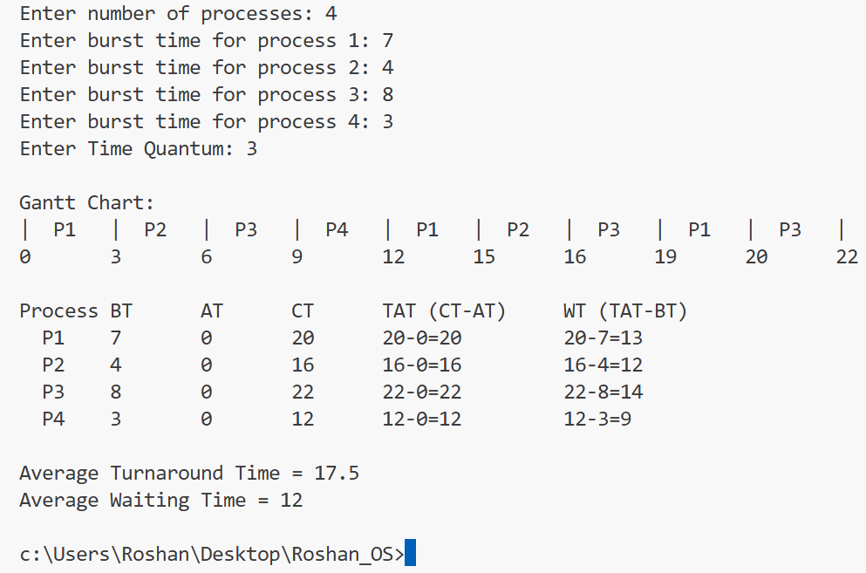

**Conclusion:**

Round Robin is fair and starvation-free because each process gets equal CPU time. It is widely used in time-sharing systems. However, its performance depends heavily on the time quantum:

* If too small → high context switching overhead.
* If too large → behaves like FCFS.